**SRA Compilation Guide**

Contents

1 Overview 5

1.1 Objectives 5

1.2 Application Scope 5

1.3 Objects to Be Compiled 5

2 Description of the Compilation Environment 5

2.1 PC Information 5

2.2 Software and Hardware Requirements 5

2.3 Tool Installation Process 6

3 Constructing a Compilation Environment 6

3.1 Installing Windows Server 2008 R2 Standard Service Pack 1 6

3.2 Installing the Compilation Tools 6

4 Version Compilation 6

4.1 Preparing for the Compilation 6

4.2 Compiling Third-Party Software 7

4.2.1 Executing Compilation Scripts 7

4.3 Compiling the SRA Software Package 10

4.3.1 Executing Compilation Scripts 10

4.4 Packing the SRA Software 11

4.4.1 Executing the Packing Script 11

4.4.2 Obtaining the SRA Software Package 11

SRA Version Compilation Guide

**Keywords**: Environment construction, compilation

**Abstract**: This guide demonstrates how to set up the SRA environment and how to compile the SRA software.

# Overview

This document aims to instruct engineers to set up the compilation environment for SRA and compile the SRA software.

## Objectives

This document introduces the processes to set up compilation environment and compile codes for SRA. By following instructions in this document, you can compile release packages of SRA.

## Application Scope

This document is intended for personnel who need to set up a compilation environment and compile software for SRA, for example:

* Software developers
* Underlying software test engineers
* Integrated delivery engineers

## Objects to Be Compiled

Objects to be complied in this guide include:

* Third-party software on which SRA depends
* SRA: **OpenSDS_Storage_SRA_v*.*.**.exe**

# Description of the Compilation Environment

## PC Information

PC : 1

CPU: 1 (2-core, 2.6 GHz)

Memory: 4 GB

Disk: 100 GB

Partition: C: 60 GB D: 40 GB

Operating system: Windows Server 2008 R2 Standard Service Pack 1

## Software and Hardware Requirements

Intel x86 architecture, 64-bit processor, 4 GB memory, 100 GB disk capacity

|  |  |  |  |  |  |
| --- | --- | --- | --- | --- | --- |
| Operating System Type | No | Bit | Configuration | Disk Partition | Remarks |
| Windows Server 2008 R2 Standard Service Pack 1 | PC1 | 64 | CPU: 1 (2-core 2.6 GHz)  Memory: 4 GB  Disk: 100 GB | C: 60 GB  D: 40 GB | N/A |

# Constructing a Compilation Environment

## Installing Windows Server 2008 R2 Standard Service Pack 1

See the installation guide provided by the operating system vendor.

## Installing the Compilation Tools

### Install Visual Studio 2012

### Install InstallShield 2010

Configuring environment variables after install InstallShied 2010:

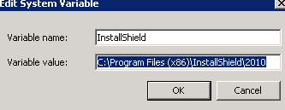

### Install Windows Driver Kit 8.1

### Install perl

# Version Compilation

## Preparing for the Compilation

* + - 1. Preparing the Source Codes

Log in the Windows host as an administrator.

Copying source codes to the Windows host

The software source codes must be saved strictly according to the code path. Otherwise, the binary files obtained after compilation may be inconsistent.

Confirm the code path that is as follows:

| source

| third_party_groupware

| build_scripts

| compile configuration file

| OpenSDS_Storage_Plugins

| thirdparty_version.txt

note

Because the source codes of third-party software downloaded from its official website can be successfully complied only after you change the project properties

Confirming the System Files Used for Compilation

Check whether file devenv**.exe** exists in the installation directory (**<Visual Studio 2012 Install Path>/Common/IDE**) of Microsoft Visual Studio 2012.

## Compiling Third-Party Software

### DownLoad the Third-Party Software

#### 4.2.1.1 Download zlib

1. Get the zlib (1.2.11) from the following address: <https://sourceforge.net/projects/libpng/files/zlib/1.2.11/zlib1211.zip/download?use_mirror=jaist&download>=

2. Unzip zlib and put it into the following directory: <SRA Path>\third_party_groupware\OpenSDS_Storage_Plugins\zlib\source

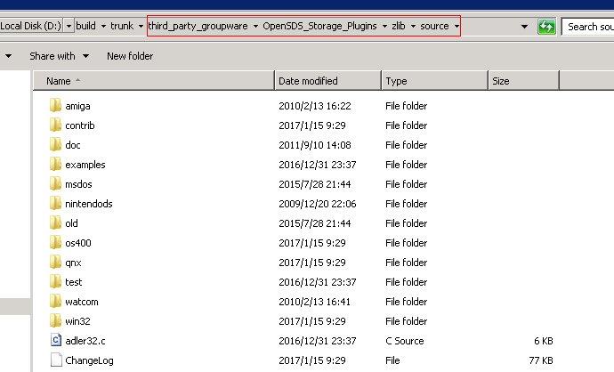

3. Replace the file folder **<SRA Path>\third_party_groupware\OpenSDS_Storage_Plugins\zlib\source\contrib\vstudio\vc11** by the file folder **<SRA Path>\third_party_groupware\compile configuration file\zlib\vc11**

#### 4.2.1.2 Download openssl

1. Get the openssl (1.1.1a) from the following address: <https://www.openssl.org/source/openssl-1.1.1a.tar.gz>

2. Unzip openssl and put it into the following directory: <SRA Path>\third_party_groupware\OpenSDS_Storage_Plugins\openssl\source

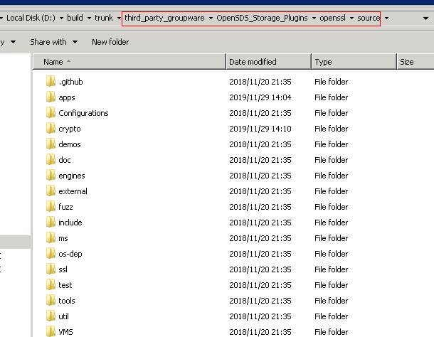

#### 4.2.1.3 Download libssh2

1. Get the libssh2 (1.8.2) from the following address: <https://github.com/libssh2/libssh2/releases/tag/libssh2-1.8.2>

2. Unzip libssh2 and put it into the following directory: <SRA Path>\third_party_groupware\OpenSDS_Storage_Plugins\libssh2

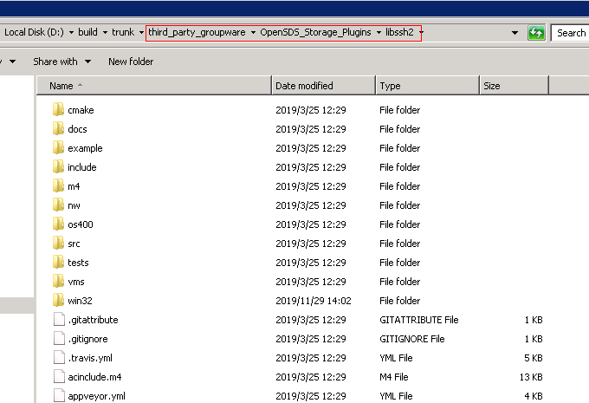

3. put all the file in the folder **<SRA Path>\third_party_groupware\compile configuration file\libssh2\** into **<SRA Path>\third_party_groupware\OpenSDS_Storage_Plugins\libssh2\win32\**

#### 4.2.1.4 Download curl

1. Get the curl (7.64.1) from the following address: <https://curl.haxx.se/download/curl-7.64.1.zip>

2. Unzip curl and put it into the following directory: <SRA Path>\third_party_groupware\OpenSDS_Storage_Plugins\curl\source

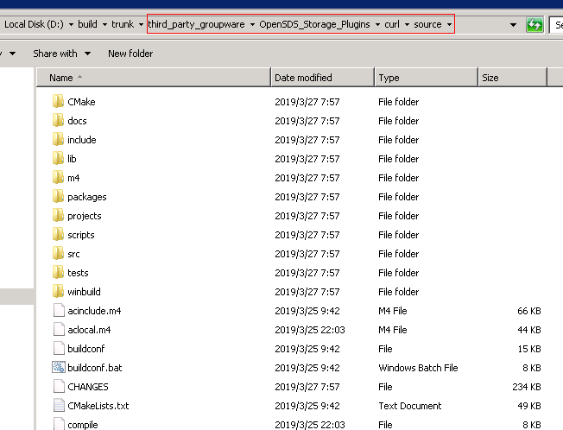

3. Replace the file folder **<SRA Path>\third_party_groupware\OpenSDS_Storage_Plugins\curl\source\projects\Windows\VC11** by the file folder **<SRA Path>\third_party_groupware\compile configuration file\curl\VC11**

#### 4.2.1.5 Download ace

1. Get the ACE (6.5.0) from the following address: <http://download.dre.vanderbilt.edu/previous_versions/ACE-6.5.0.tar.gz>

2. Unzip ACE and put it into the following directory: <SRA Path> \third_party_groupware\OpenSDS_Storage_Plugins\ACE\source

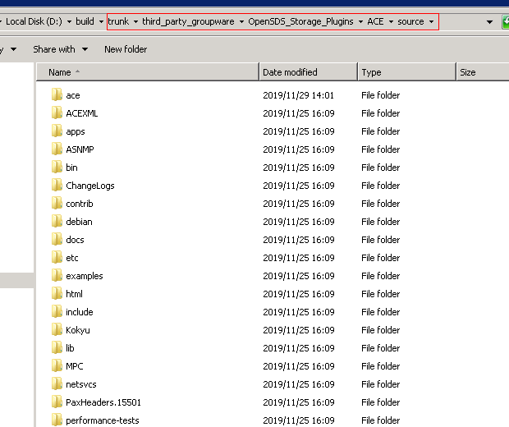

3. Replace the file ace_vc12.sln, ACE_vc12.vcxproj, ACE_vc12.vcxproj.filters,config.h in **<SRA Path>**\**third_party_groupware\OpenSDS_Storage_Plugins\ACE\source\ace** by the file in folder **<SRA Path>\third_party_groupware\compile configuration file\ace\ace.**

Replace the file SSL.vcxproj in **<SRA Path>**\**third_party_groupware\OpenSDS_Storage_Plugins\ACE\source\ace\ssl** by the file in folder **<SRA Path>\third_party_groupware\compile configuration file\ace\ssl**

#### 4.2.1.6 Download jsoncpp

1. Get the jsoncpp (0.10.6) from the following address: <https://github.com/open-source-parsers/jsoncpp/archive/0.10.6.tar.gz>

2. Unzip jsoncpp and put it into the following directory: <SRA Path>\third_party_groupware\OpenSDS_Storage_Plugins\jsoncpp\source

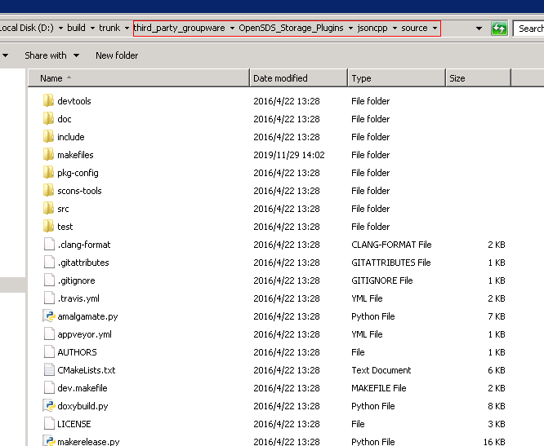

3. Replace the file folder **<SRA Path>\third_party_groupware\OpenSDS_Storage_Plugins\jsoncpp\source\makefiles\msvc2010** by the file folder **<SRA Path>\third_party_groupware\compile configuration file\jsoncpp\msvc2010**

#### 4.2.1.7 Download tinyxml

1. Get the tinyxml (2.6.2) from the following address: <https://sourceforge.net/projects/tinyxml/files/latest/download>

2. Unzip tinyxml and put it into the following directory: **<SRA Path>\third_party_groupware\OpenSDS_Storage_Plugins\tinyxml\source**

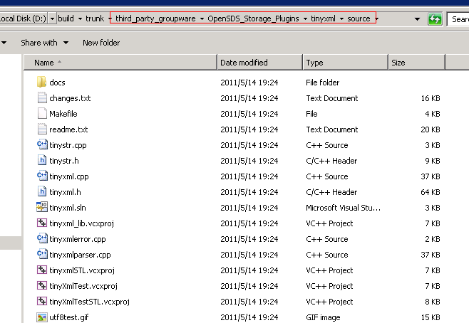

### 4.2.2 Executing Compilation Scripts

Log in to the Windows host. In **Start**, enter **cmd** to enter the command window, as shown in the following figure.

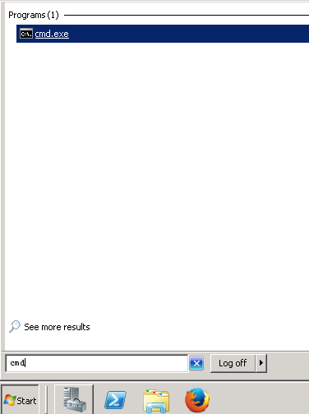

On the CLI, run the **cd** *save directory of the compilation scripts* command ( **cd <SRA Path>\third_party_groupware\build_scripts**). Then, run the **dir** command to check files exist in the current directory, as shown in the following figure.

**----End**

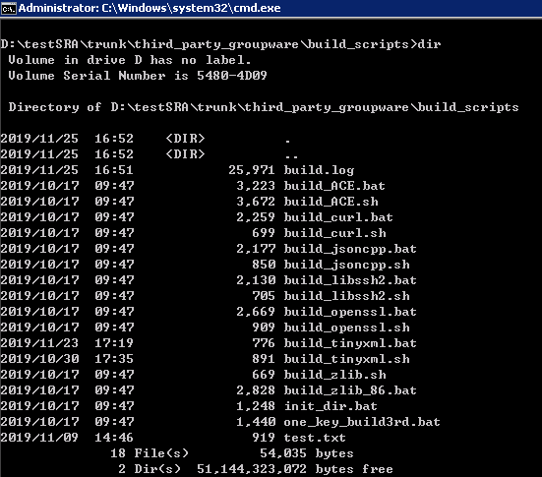

Run script **init_dir.bat** to initialize the directory, as shown in the following figure.

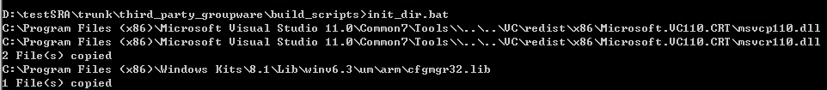

Run script **one_key_build3rd.bat** to compile the third-party software, as shown in the following figure.

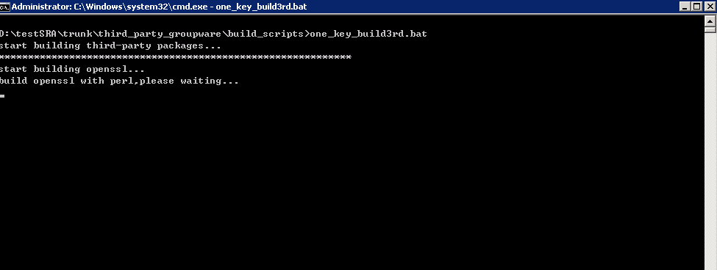

Compilation logs are saved in file **build.log** under the current directory.

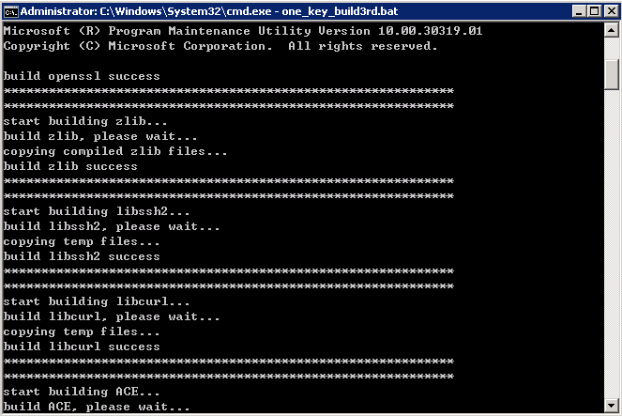

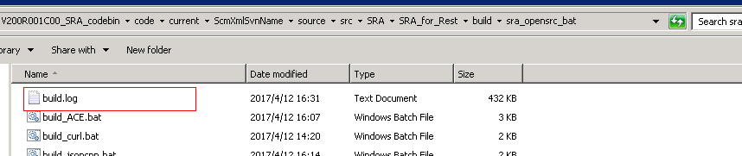

**----End**

## Compiling the SRA Software Package

### Executing Compilation Scripts

On the CLI, run the **cd** *save directory of the compilation scripts* command (**cd <SRA path>\source\build**) to go to the save directory of the compilation scripts.

Run script **sra_rest_no3rd.bat** to compile the SRA software, as shown in the following figure.

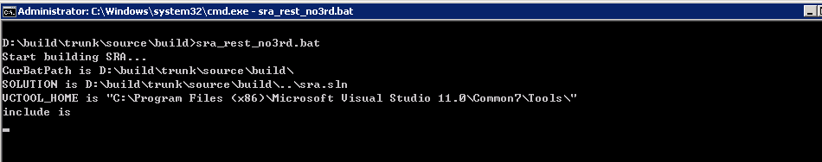

Compilation logs are saved in file **build.log** under the current directory.

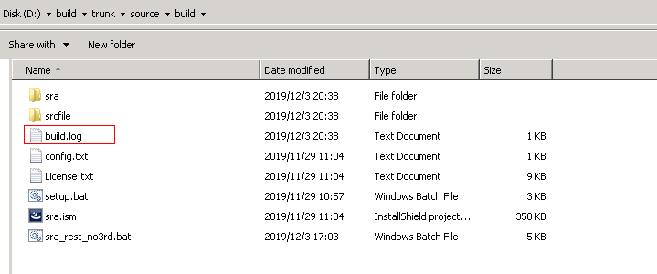

**----End**

## Packing the SRA Software

### Executing the Packing Script

On the CLI, run the **cd** *save directory of the compilation scripts* command (**cd <SRA Path> \source\build**) to go to the save directory of the compilation scripts.

Run script **setup.bat** to pack the SRA software, as shown in the following figure.

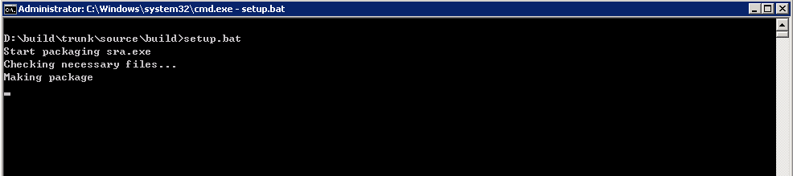

Compilation logs are saved in file **build.log** under the current directory.

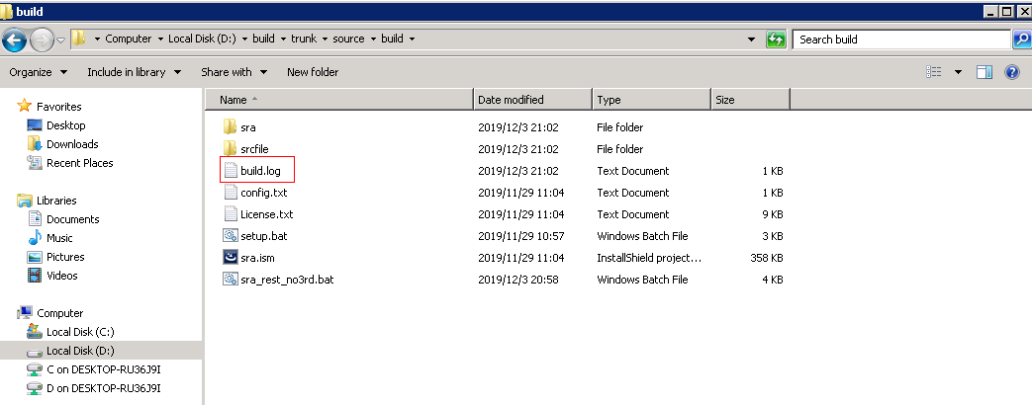

**----End**

### Obtaining the SRA Software Package

After the previous operations, the SRA software package has been compiled and saved in:

**<SRA Path>\source \build\sra\PROJECT_ASSISTANT\ SINGLE_EXE_IMAGE\DiskImages\DISK1**

